

Applied DevOps

Phase 3



December 5, 2023

19F-0911 Tayyab Shahid

19F-0969 Suneel Pirkash

19F-0976 Shayan Ilyas

# **Phase 3:**

## **Task 01:**

* Selected Project 2 from given Projects

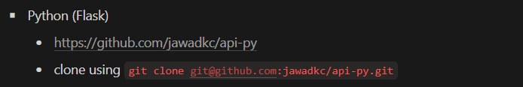

* Docker File Running

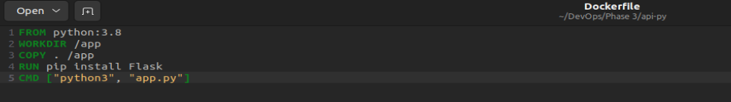

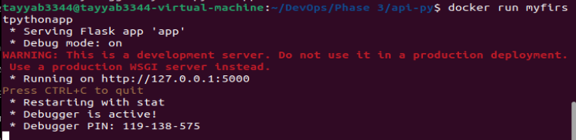

* Docker Container Building

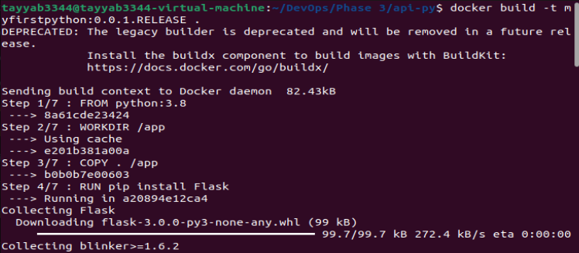

* Docker Container Running



## **Task 02 (Kubernetes + Helm Chart + Minikube):**

* Kubernetes Cluster Running

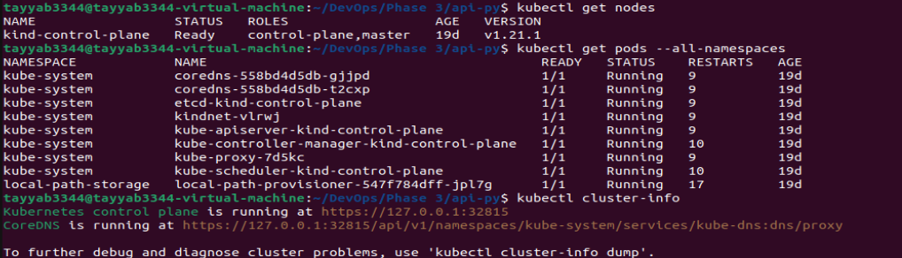

* Kubernetes Cluster Setting and Helm Installation

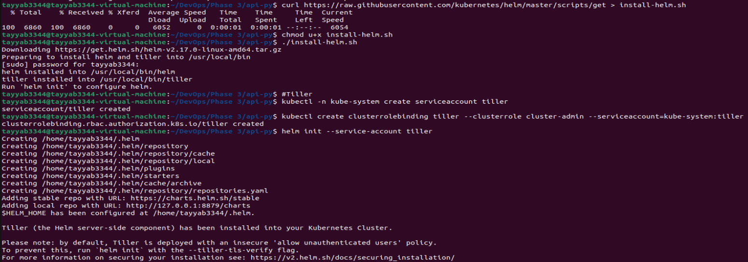

* Kubernetes Cluster Deployed

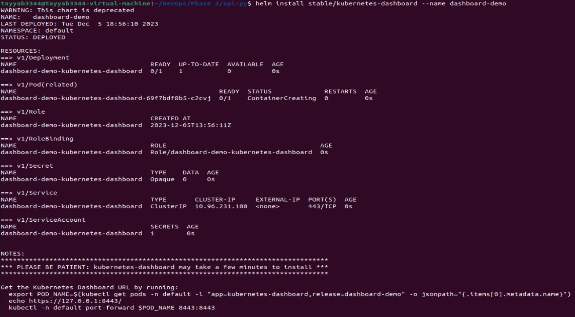

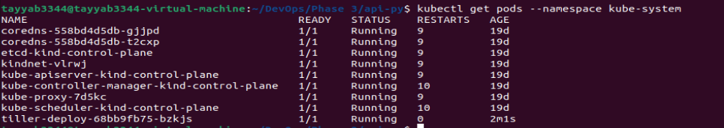



* Deploying on Kubernetes

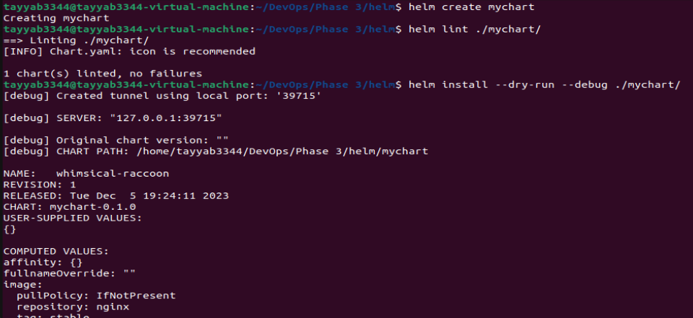

* Deployed on Kubernetes





# **Task 03:**

